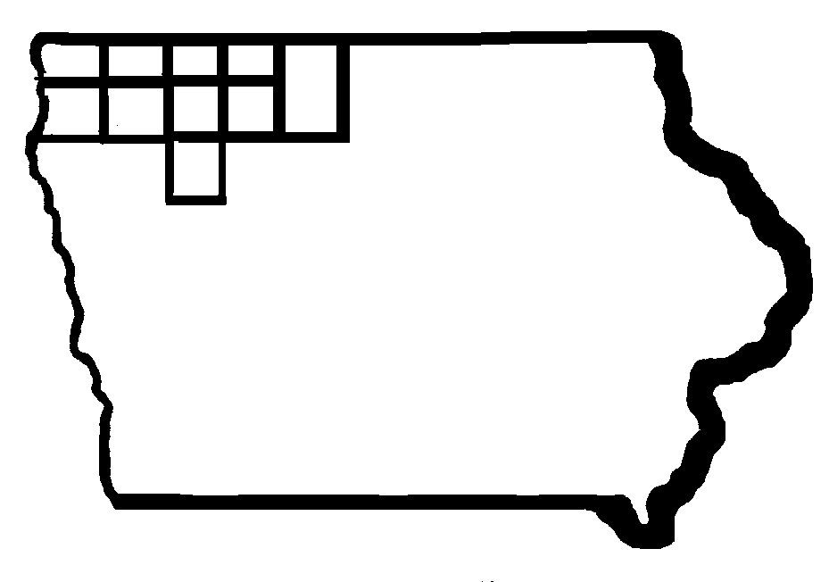

Iowa Region 3 & 4

Youth Advisory Council

AGENDA

Region 3-4 Youth Advisory Council
Friday, April 25, 2014

Governmental Services Building
217 West 5th Street – Room B
Spencer, Iowa
9:30 a.m.

Welcome

Approval of July, 2013 Minutes

Final Region 3-4 Workforce Investment Act Youth Performance Measures – PY 12

Progress Report - YAC Priorities
Marketing Youth Services based on Multiple Agencies
Utilize Success Stories in Marketing Youth Services
Focus on Work Readiness Skills
Follow –Up on Referrals for Youth Not in WIA Program

Next Steps – Future Focus Region 3-4 YAC

Next Meeting Date – July 25, 2014

